Kem Chan
CS 405 Secure Coding
Oct 4, 2026
Assignment 5 – Static Code Analysis

Output Screenshots
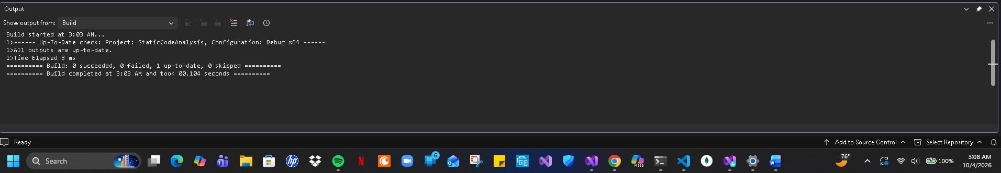
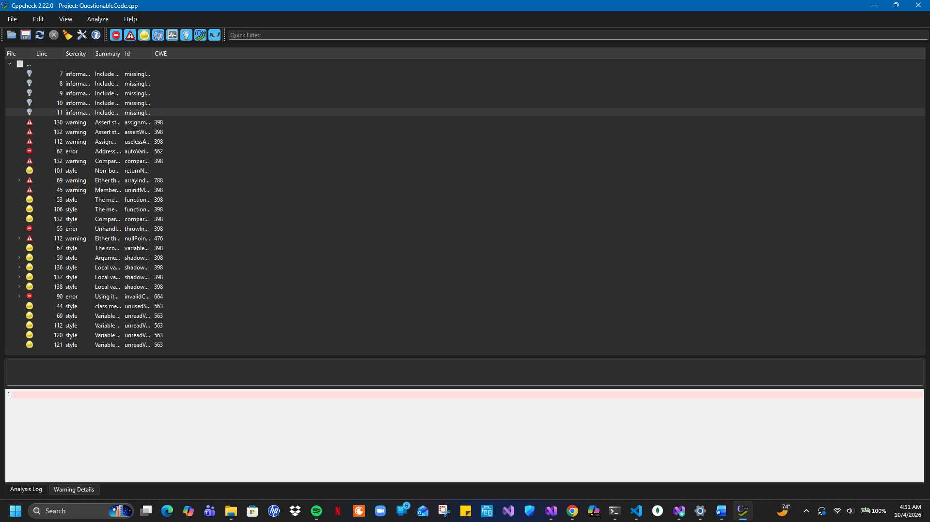
Summary
Looking at both screenshots you can see all of the issues from the static code analysis flagged in visual Studio as well as Cppcheck. Visual Studio located several issues while on the other hand Cppcheck located significantly more that were not found in Visual Studio. In addition, the issues where both analysis tools flagged a problem of the issue descriptions were more verbose and informative in Cppcheck in comparison to Visual Studio. Visual Studio labeled all the issues only as warnings while Cppcheck gave more information as well as assigning each issue severity level for information, style, warning, or error.

